Practical - 9
Practical Title: Secure User Registration with Database Insert, Duplicate Email Check, and Password Hashing
Problem Definition: Implement secure user registration by inserting user details into MySQL using MYSQLi. Validate input on frontend and backend, check duplicate email/username, hash passwords using password_hash(), and display appropriate messages.
Theory:
- Is password_hash() used before storing passwords?
Ans: Yes, passwords are encrypted using password_hash($password, PASSWORD_DEFAULT) before database insertion to ensure plaintext credentials are never stored.
- Is duplicate email/username checked?
Ans: Yes, a MySQLi prepared statement queries the database to check if the entered email or enrollment number already exists before executing the insert.
- Are frontend and backend validations consistent?
Ans: Yes, both frontend (HTML5/JavaScript) and backend (PHP) enforce the same validation rules for mandatory fields, valid email syntax, minimum password length, and password matching.
Implementation/ Output/Result :
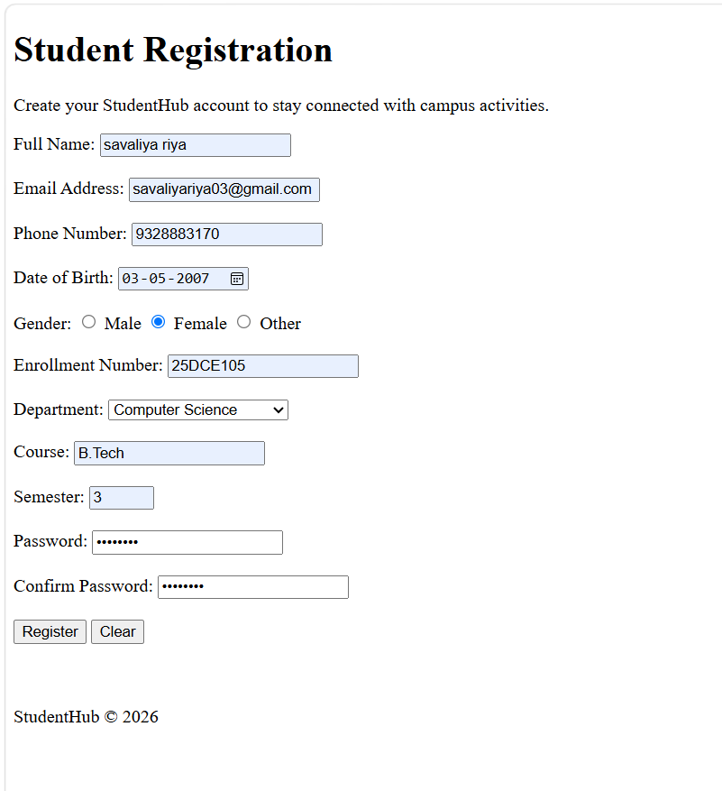

- GitHub Repository Link:
StudentHub/MySQLi at main · savaliyariya03/StudentHub
- Challenges Faced:
I faced challenges in MySQLi understanding and implementation code.

- Learning Outcomes:
Now I understand MySQLi for database connection and how to handle duplication in registration.
- Faculty Remarks:

